Nor Suraya Binti Abdul Razak

+60134011548 / norsurayarozita@gmail.com

28 July 2025

## **Word Document Section: Terminal Output Demonstration**

### **Running the Application and Observing Output**

This section demonstrates running the app.py console application with various input scenarios by passing different JSON input files as command-line arguments. The application's output, including the input parameters and the calculated cheapest price, is displayed directly in the terminal.

#### **1. Test Case: Example 1**

This test case uses input_example1.json as input.

**Input File Content (input_example1.json):**

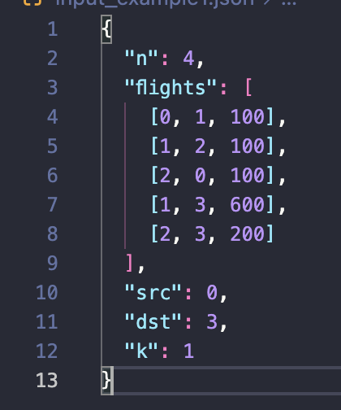

**Terminal Command and Output:**



**Description:** For input_example1.json (n=4, flights=[[0,1,100],[1,2,100],[2,0,100],[1,3,600],[2,3,200]], src=0, dst=3, k=1), the application correctly calculates the cheapest price as **700**.

#### **2. Test Case: Example 2**

This test case uses input_example2.json as input.

**Input File Content (input_example2.json):**

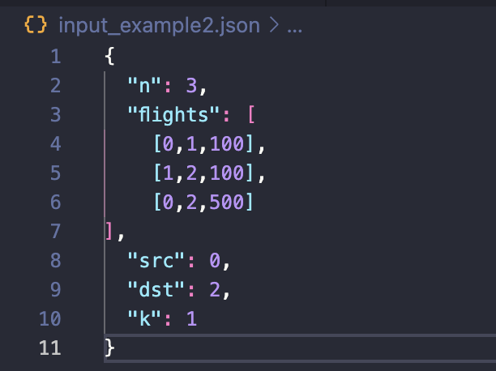

**Terminal Command and Output:**



**Description:** For input_example2.json (n=3, flights=[[0,1,100],[1,2,100],[0,2,500]], src=0, dst=2, k=1), the application correctly calculates the cheapest price as **200**. This corresponds to the path 0 -> 1 -> 2.

#### **3. Test Case: Example 3**

This test case uses input_example3.json as input.

**Input File Content (input_example3.json):**

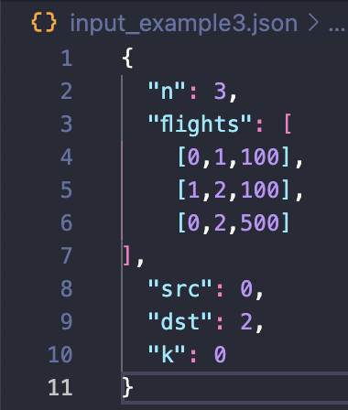

**Terminal Command and Output:**



**Description:** For input_example3.json (n=3, flights=[[0,1,100],[1,2,100],[0,2,500]], src=0, dst=2, k=0), the application correctly calculates the cheapest price as **500**. This corresponds to the direct path 0 -> 2.